National Teen Driver Safety Week (October 16-22, 2022)
Social Content
Graphic | Suggested Post Copy
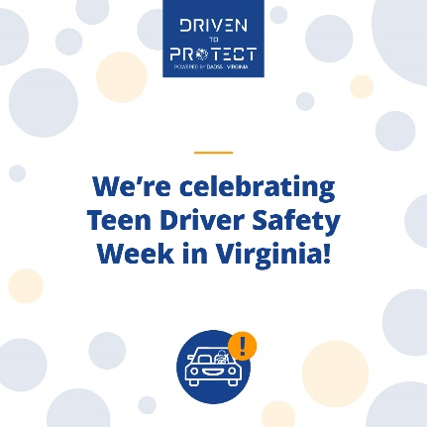 | For parents, @DADSSTech will provide peace of mind by ensuring their child won’t be able to drive while intoxicated. Learn more about the lifesaving technology that will prevent drunk driving at DrivenToProtectVa.org
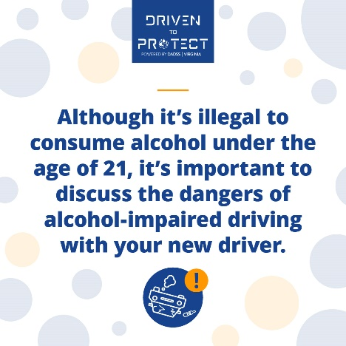 | According to @NHTSAgov, alcohol is one of the greatest dangers for teen drivers. That’s why it’s never too early to talk to your teen about why they should never drink and drive. And it’s why @DrvnToProtectVA is committed to advancing technology that could end drunk driving for good.
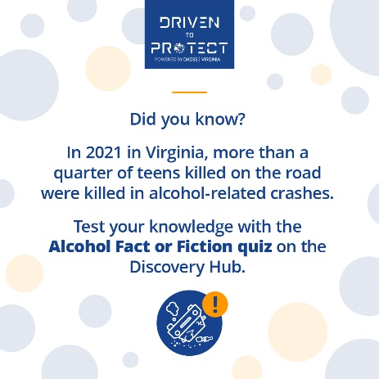 | Are you aware of the dangers teen drivers face on the road? Take the Alcohol Fact or Fiction quiz on the @DrvnToProtectVA Discovery Hub to test your knowledge about the dangers of alcohol-impaired driving: https://bit.ly/3qQzMCO
New Discovery Hub Intro Video | #TeenDriverSafetyWeek is the perfect time to visit the @DrvnToProtectVA Discovery Hub and learn about the innovative technologies currently being developed to make our roads safer by preventing drunk driving.  https://youtu.be/Hg9MLhkoBV8

