How to Register and Pay for a VADETS Course
- Go to https://vadriveredcourses.vadets.info/.
- Choose a course. (NOTE: District 8 students must choose District 8 Only Course)
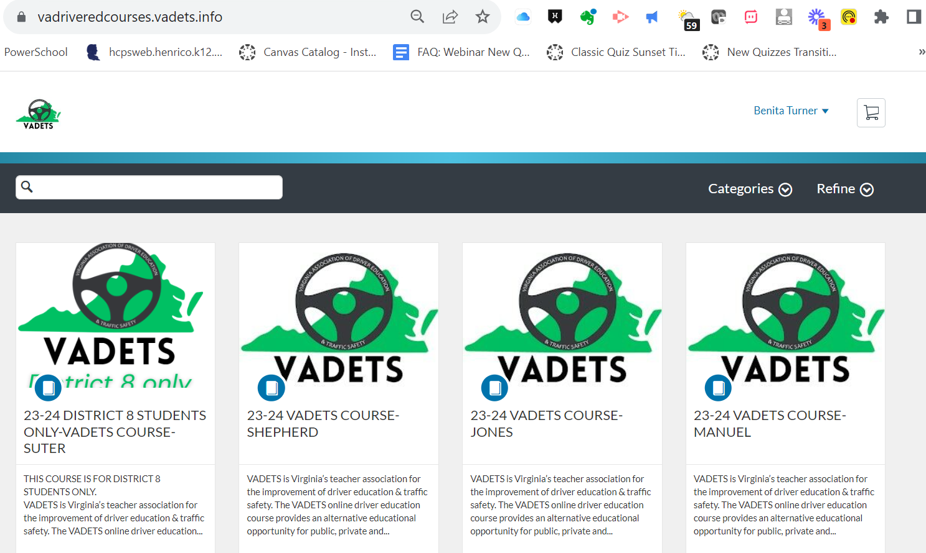

- Click $119 Enroll Now.

- If you already have a VADETS Canvas account click Signin. Otherwise, answer all the questions to create a new account. (Most people will create a new account). Note: You cannot use your School Canvas account to login.
- Once you answer all of the questions, Agree to the Policies, select I’m not a Robot and click Register New Account.
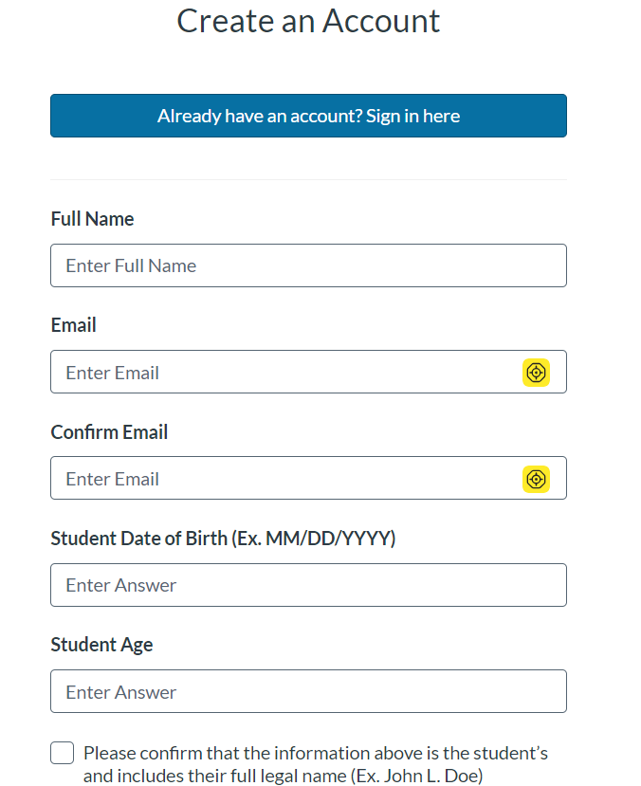
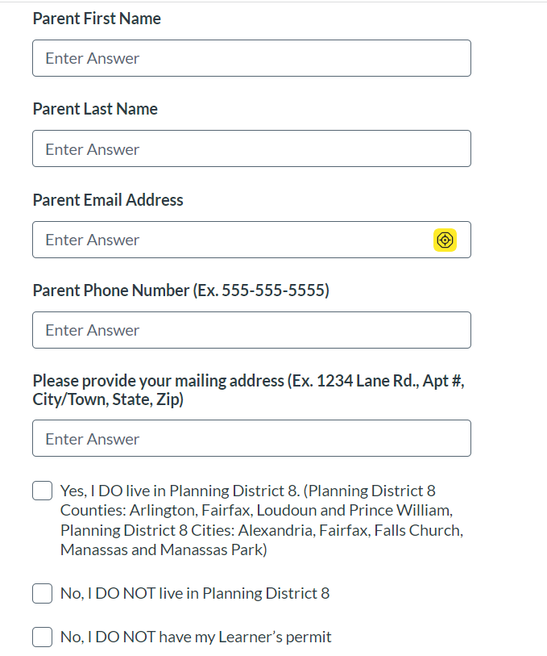
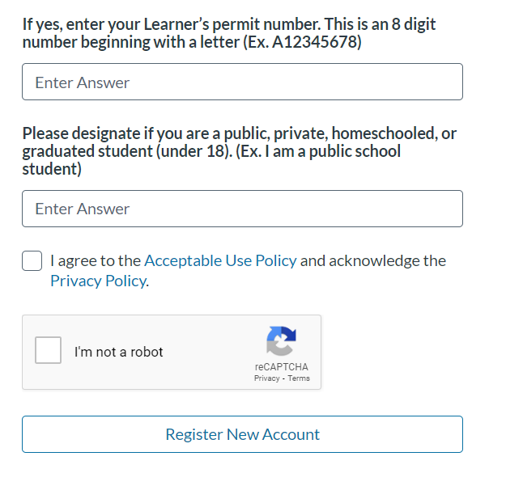
- Once you register a new account you will receive an email from Canvas Catalog-notifications@instructure.com that says you have successfully registered for a new account and that you need to complete Registration by setting up your password.
- You MUST click the Complete Registration button.
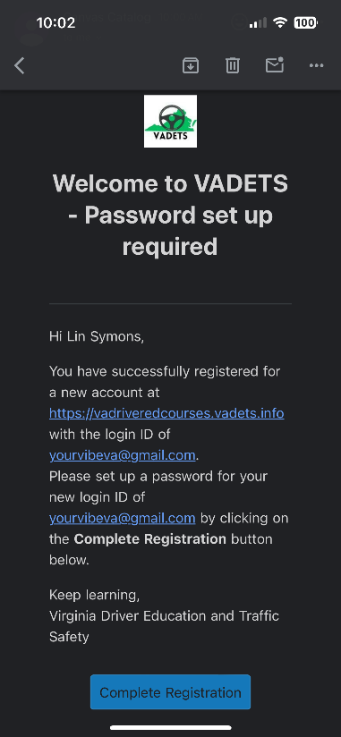
- At the same time you receive the email to set up your password, your screen will come up to Pay and Enroll.
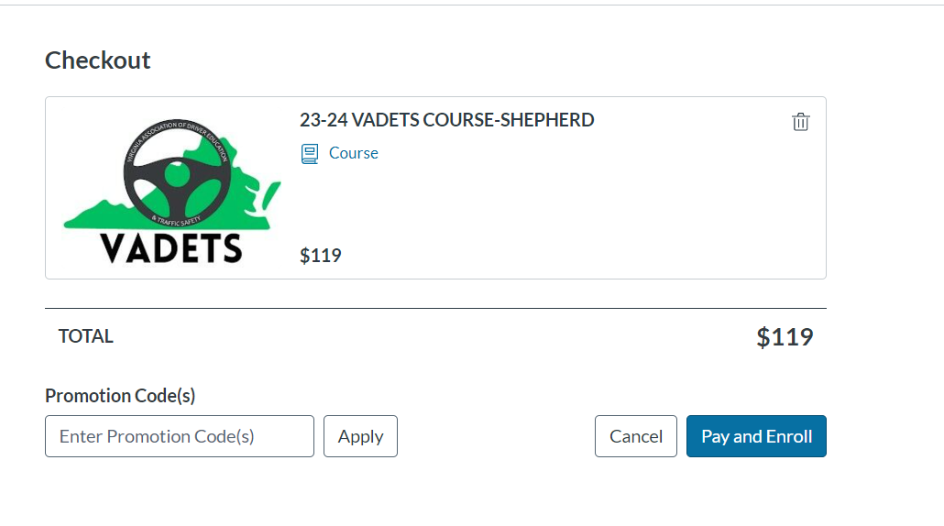
- Fill in Payment information and click Pay Now
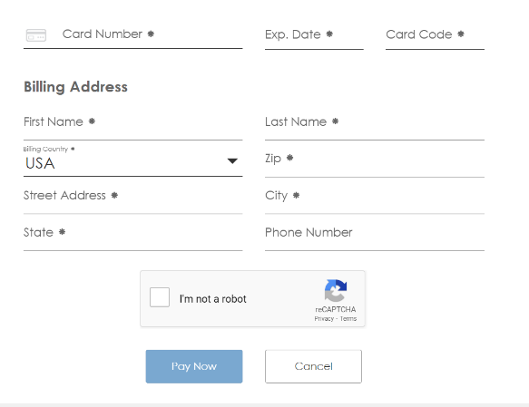

- When you click the Complete Registration button from your email, you will type in a password for the VADETS Course and click Register. (Note: Your login, which is your email address, will appear in the box.)
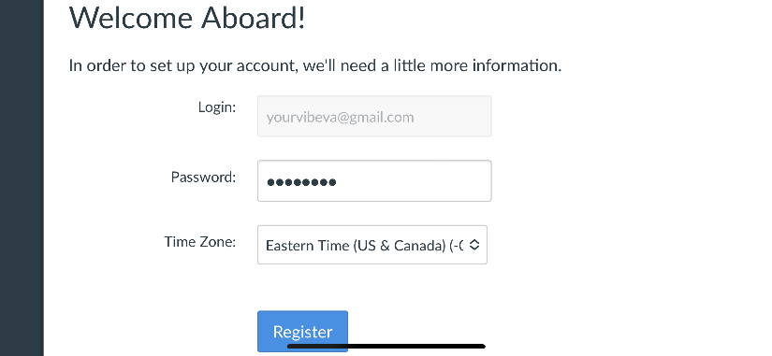

- Click Go To Courses.
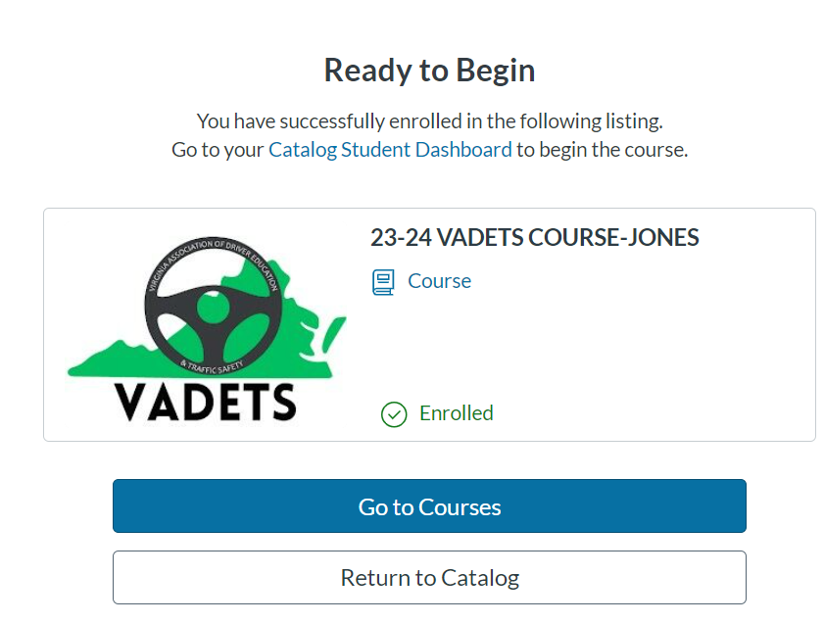
- Click Begin Course or go to https://vadets.instructure.com/login/canvas and login with your email as your username and the password you recently set up. (Note: The ending date for the course is noted under the course name)
